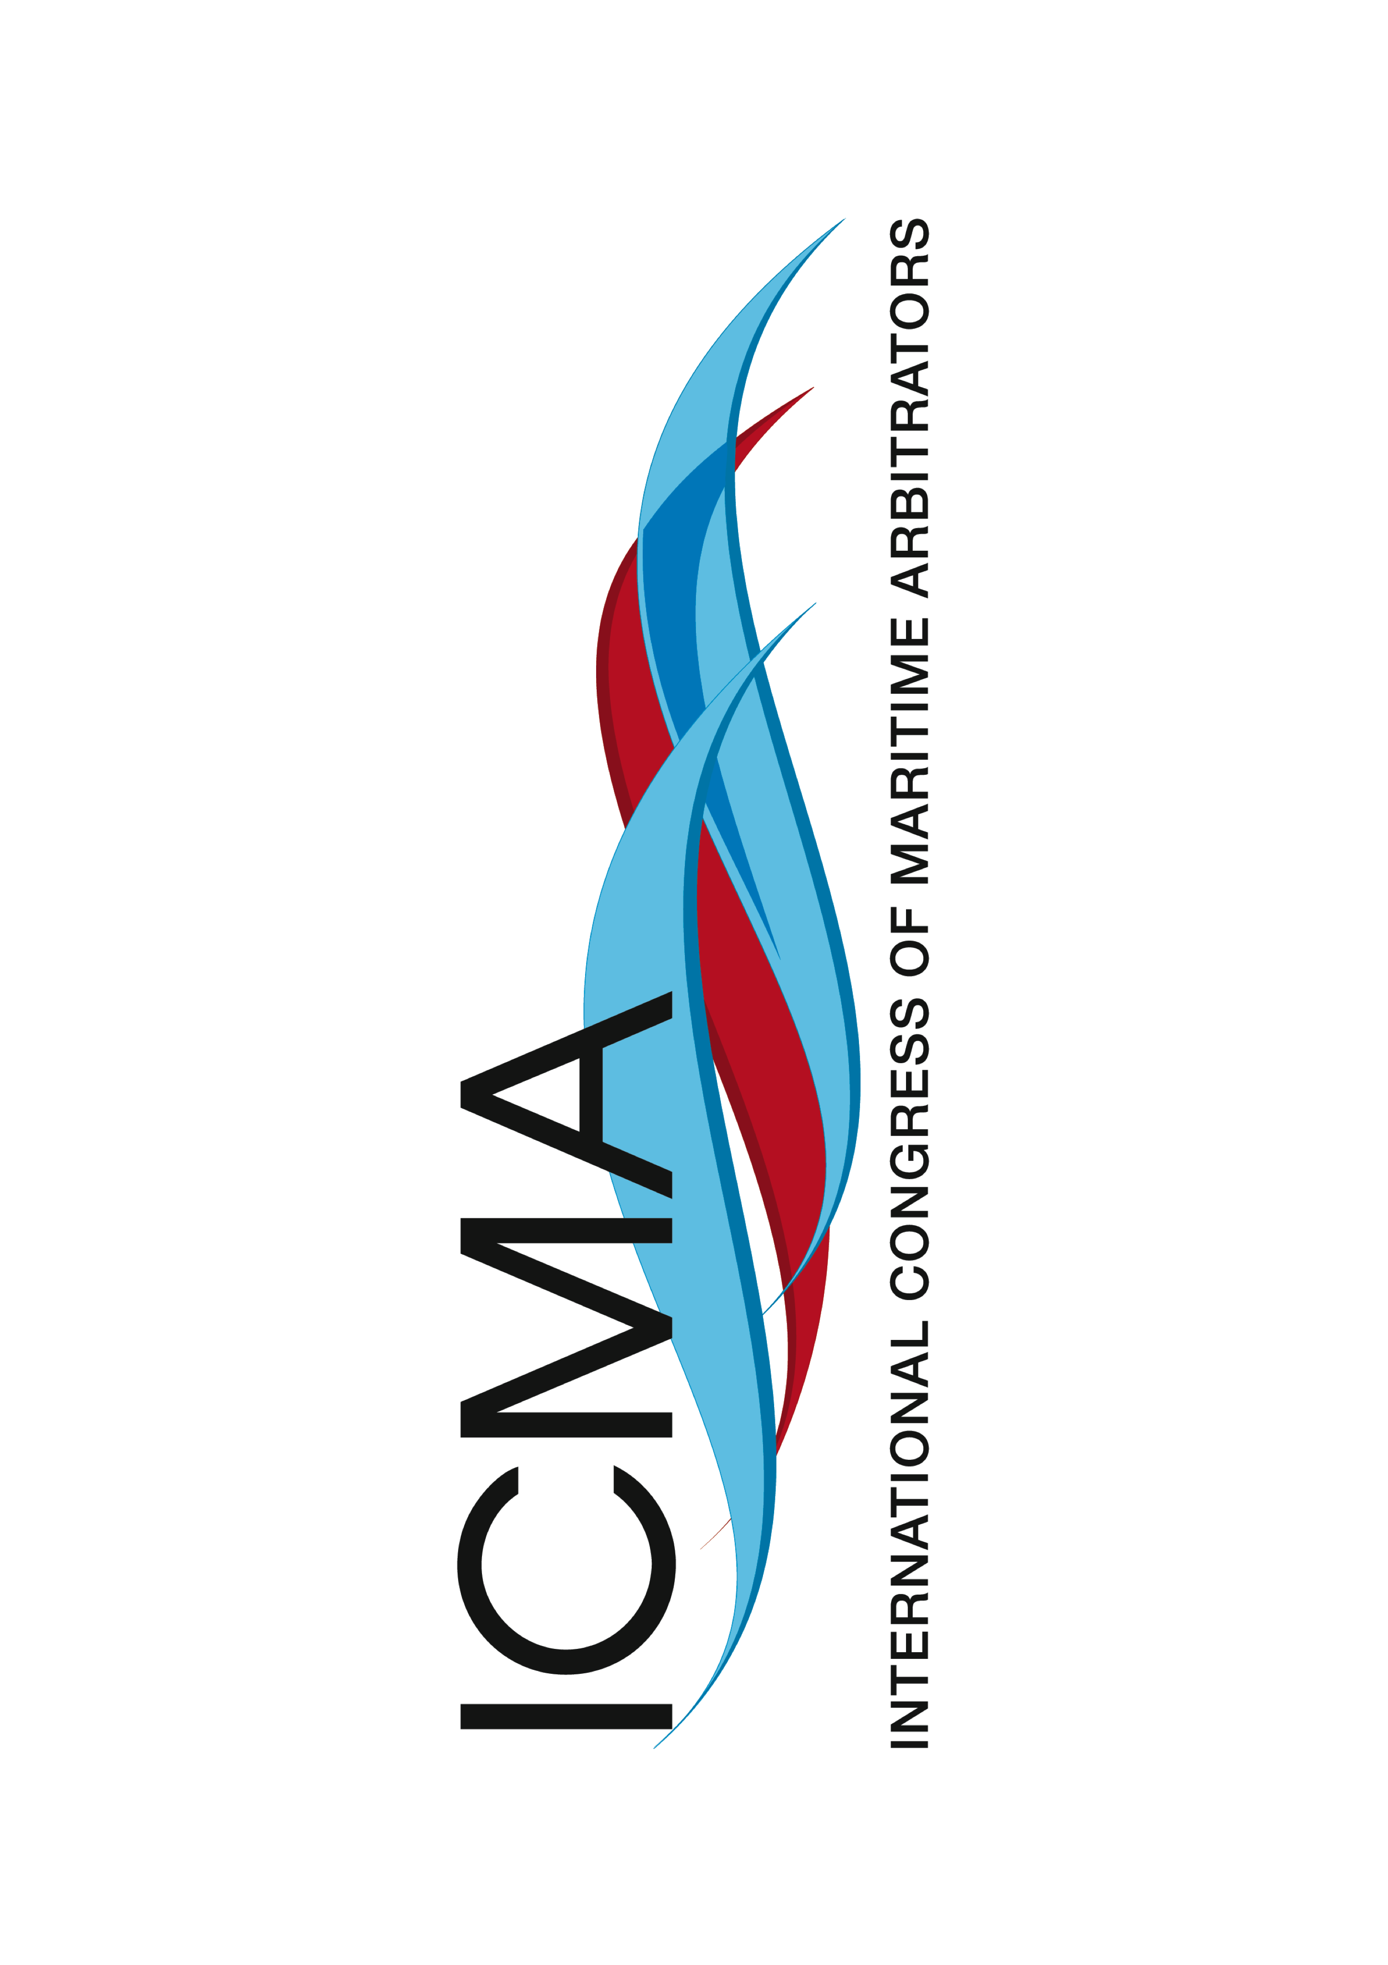

ICMA XIX Hong Kong – 11 to 15 May 2015

**Highlights of the event**:

* Cedric Barclay Memorial Lecture “**Contributions to the English law of contract that started life as maritime arbitrations in Cedric's day”** to be given by **Lord Phillips of Worth Matravers**, the former President of the Supreme Court of the United Kingdom
* Join the world’s top maritime arbitrators, lawyers and counsel
* **Over 100 speakers** will present summaries of their papers, which will cover the most important and topical issues of maritime arbitration and substantial law and practice
* All papers submitted by those attending the Congress will be made available on a USB stick to all registered delegates
* **A mock arbitration** will be held by 20 Essex Street and Quadrant Chambers
* **Extensive social programme**, both for delegates and accompanying persons
* Visit to the **Hong Kong International Arbitration Centre** and to the **Hong Kong Maritime Museum**
* Exclusive opportunity to join delegates to the ICCA-HKIAC HK Summit at the **Happy Valley Racecourse**

Register Now at:

www.ICMA2015HongKong.org



A division of the  
Hong Kong International Arbitration Centre